Customer Shopping Behavior Analysis

Project Overview
This project analyzes customer shopping behavior using transactional data from 3,900 purchases across various product categories. The goal is to uncover insights into spending patterns, customer segments, product preferences, and subscription behavior to guide strategic business decisions.

Dataset Summary
- Rows: 3,900
  - Columns: 18
  - Key Features:
    - Customer demographics (Age, Gender, Location, Subscription Status)
    - Purchase details (Item Purchased, Category, Purchase Amount, Season, Size, Color)
    - Shopping behavior (Discount Applied, Promo Code Used, Previous Purchases, Frequency of Purchases, Review Rating, Shipping Type)
  - Missing Data: 37 values in Review Rating column

Exploratory Data Analysis using Python
We began with data preparation and cleaning in Python:

- Data Loading: Imported the dataset using pandas.

- Initial Exploration: Used df.info() to check structure and .describe() for summary statistics.
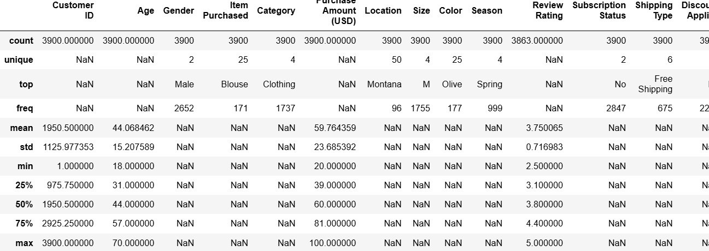

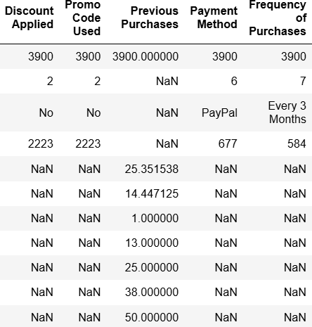

- Missing Data Handling: Checked for null values and imputed missing values in the
Review Rating column using the median rating of each product category.

- Column Standardization: Renamed columns to snake case for better readability and documentation.

- Feature Engineering:

  - Created age_group column by binning customer ages.

  - Created purchase_frequency_days column from purchase data.

- Data Consistency Check: Verified if discount_applied and promo_code_used
were redundant; dropped promo_code_used.

- Database Integration: Connected Python script to PostgreSQL and loaded the cleaned DataFrame into the database for SQL analysis.

Data Analysis using SQL (Business Transactions)
We performed structured analysis in PostgreSQL to answer key business questions:

- Revenue by Gender – Compared total revenue generated by male vs. female customers.

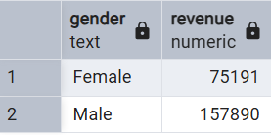

- High-Spending Discount Users – Identified customers who used discounts but still spent above the average purchase amount.
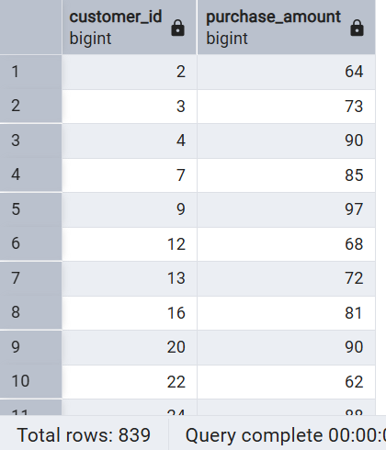

- Top 5 Products by Rating – Found products with the highest average review ratings.

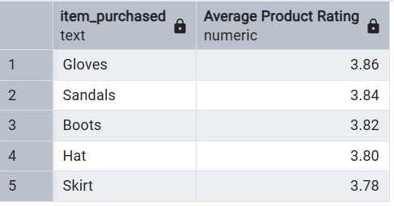

- Shipping Type Comparison – Compared average purchase amounts between Standard and Express shipping.
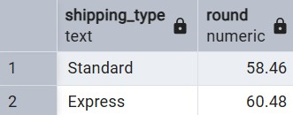

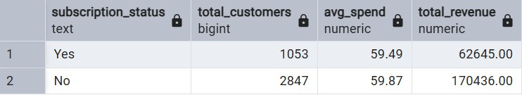
- Subscribers vs. Non-Subscribers – Compared average spend and total revenue across subscription status.

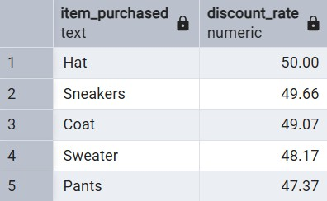
- Discount-Dependent Products – Identified 5 products with the highest percentage of discounted purchases.

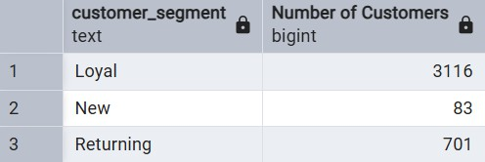
- Customer Segmentation – Classified customers into New, Returning, and Loyal segments based on purchase history.

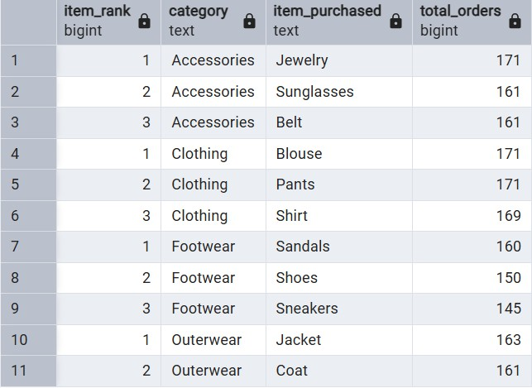
- Top 3 Products per Category – Listed the most purchased products within each category.
- Repeat Buyers & Subscriptions – Checked whether customers with >5 purchases are more likely to subscribe.
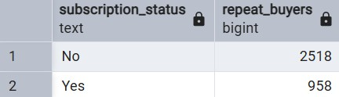
- Revenue by Age Group – Calculated total revenue contribution of each age group.

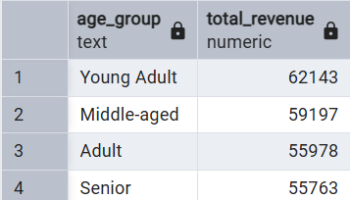

- Top 5 locations by average purchase: Calculated top 5 locations with highest average purchase amount

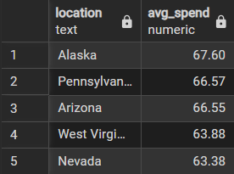

Key Business Insights

Revenue and Demographics

Gender Performance: Male customers represent the dominant revenue stream, contributing $157,890 compared to $75,191 from female customers.

Generational Drivers: Young Adults lead in total revenue contribution at $62,143, closely followed by middle-aged consumers at $59,197

Subscription & Loyalty Dynamics

The Subscription Gap: While non-subscribers currently drive higher total revenue due to volume ($170,436), the average spend per transaction remains remarkably consistent between both groups (~$59).

Loyalty Retention: Our segmentation reveals a massive Loyal base of 3,116 customers with over 10 previous purchases, compared to only 83 "New" customers. This indicates a strong retention rate but a potential need for better top-of-funnel acquisition.

Product & Shipping Performance

Top Rated Products: Gloves and Sandals hold the highest customer satisfaction scores with average ratings of 3.86 and 3.84 respectively.

Logistics Impact: Customers opting for Express shipping spend slightly more on average ($60.48) than those using Standard shipping ($58.46).

Dashboard in Power BI

Finally, we built an interactive dashboard in Power BI to present insights visually.
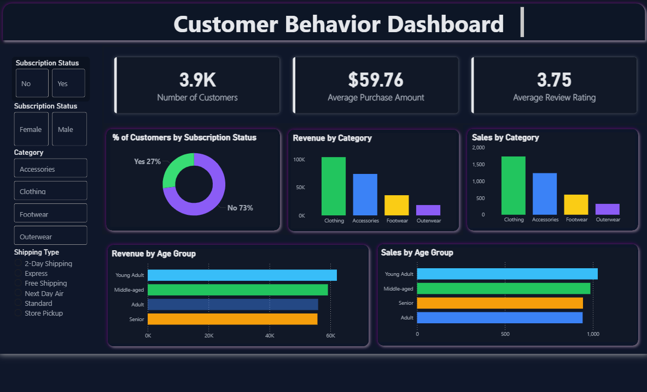

Business Recommendations

- Boost Subscriptions – Promote exclusive benefits for subscribers.

- Customer Loyalty Programs – Reward repeat buyers to move them into the “Loyal” segment.

- Review Discount Policy – Balance sales boosts with margin control.

- Product Positioning – Highlight top-rated and best-selling products in campaigns.

- Targeted Marketing – Focus efforts on high-revenue age groups and express-shipping users.

Changes that can be implemented at the earliest

Based on the multi-tool analysis conducted, we recommend the following actions to optimize ROI:

- Hyper-Personalized Marketing: Target the Young Adult and Middle-aged segments with premium Clothing and Accessories, as these categories are the primary revenue drivers.

- Conversion of "Loyal" to "Subscribed": With 958 repeat buyers already subscribed, there is a significant opportunity to convert the remaining 2,518 repeat buyers into subscribers through exclusive "Loyalty-to-Subscription" incentives.

- Discount Optimization: Focus discount strategies on Hats and Sneakers, which show the highest discount dependency (near 50%), to move inventory without eroding margins on high-rated items like Gloves.

- Logistics Upselling: Since Express shipping users show higher average spending, consider offering "Free Express Shipping" as a milestone reward for the "Returning" customer segment to push them into the "Loyal" tie .

